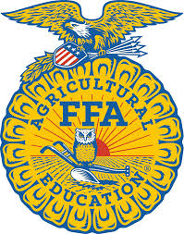
2024 Southeastern FFA Fruit Sale Prices

Citrus Items Full case ½ case 10-lb. box
Navel Oranges $36.00 $24.00 $18.00
Red Grapefruit $37.00 $24.00 $19.00
Mandarin Oranges n/a n/a $27.00

Mix/Variety Items ½ case size 3-gal Bucket
NEW! FFA Variety Bucket n/a $45.00
Navel/Grapefruit Mix $30.00
*Fresh Fruit Sampler $33.00
Pears $34.00
Pear/Red Apple Combo $31.00
Sweet potatoes $23.00

Apple Items Full case ½ case 10-pound bag Kit
NEW! Apple Nacho Kit n/a n/a n/a $25.00
Red Delicious Apples $42.00 $24.00 $15.00
Gold Delicious Apples $42.00 $24.00 $15.00
Fuji Apples $42.00 $24.00 $15.00
Evercrisp Apples $42.00 $24.00 $15.00
Granny Smith Apples $42.00 $24.00 $15.00
*Apple Variety Pack n/a $30.00 n/a

*Fresh Fruit sampler contains: grapefruit, navels, mandarins, red delicious apples, pears

*Apple Mix contains: variety of red delicious, granny smith, gold delicious & others

**Note: Some fruit varieties are either increased in price or unavailable due to the effects of higher cost of transportation, supply chain issues or the hurricane season.

-Other items for sale: D.B. Yummers BBQ sauce, BuffLo Dip, Pearl Valley Cheese, a variety
of nuts from Florida Farm Bureau and apple cider.

! - This is a pre-pay sale. Please make checks payable to: Southeastern FFA

+ Orders & payments must be turned in by: Wednesday, November 20, 2024

-NEW Products this year! Info on the back! →

-Thank you for supporting Southeastern FFA!

!!NEW FOR 2024!!

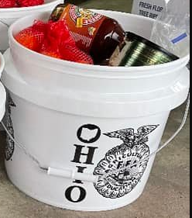
FFA Fruit Sale Variety Bucket - $45

Not sure what to order, but want a taste of everything? This 3-gallon Ohio FFA plastic bucket contains 1 brick of Pearl Valley marble cheese, 3 navel oranges, 6 mandarin oranges, 3 red grapefruits, 2 pears, 3 evercrisp apples, 3 golden delicious apples, 1 can of honey crunch peanuts, 1 jar of Buff’Lo Dip, and 1 bottle of DB Yummers sweet & smoky BBQ sauce.

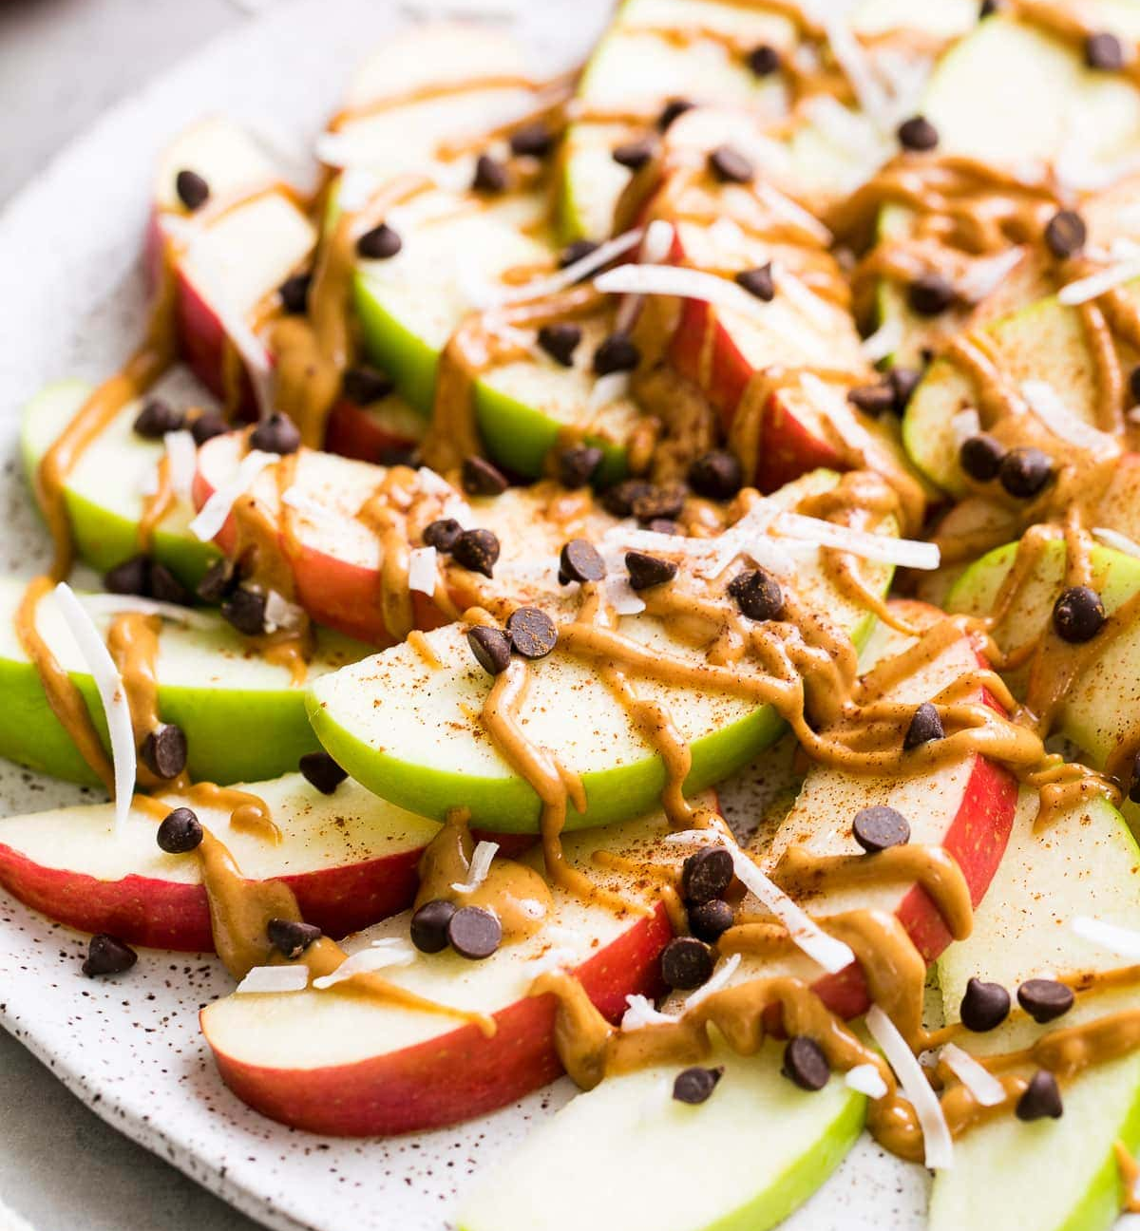
DIY Apple Nachos Kit - $25

Perfect for your family gatherings! This kit contains 2 of each apple variety (Red Delicious, Gold Delicious, Fuji, Evercrisp & Granny Smith), caramels, 1 can of Southern Fried Skinless Peanuts, and chocolate candy topping.

*NOTE: Apple slicer not included*

